EXPERIMENT 4
Name: Padma Priya D Roll No: 240701377
Create a prototype with familiar and unfamiliar navigation elements. Evaluate ease of use with different user groups using proto.io
- Home Screen:
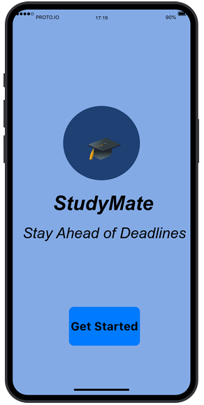

Familiar Elements:
- App Logo (Center):
o Most mobile apps display logo in the center during launch.
o Users recognize this as the starting screen.
- “Get Started” Button:
o Common call-to-action button used in onboarding screens.
o Clicking it takes the user to the next screen.
- Center Aligned Layout:
o Many apps use centered content for welcome screens.
o Easy to understand and visually balanced.
Possibly Unfamiliar Elements:
- Minimal Design Without Skip Option:
o Some apps provide multiple onboarding slides.
o Here only one simple welcome screen is used.
- Blue Theme Background:
o Though common, users may associate different colors with productivity apps.
- Login Screen :
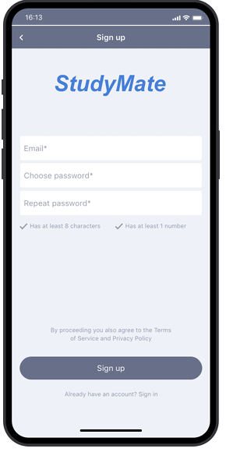

Familiar Elements:
- Email Text Field:
o Standard input field for login.
o Used in almost all applications.
- Password Field (Hidden Characters):
o Common security feature.
o Characters are hidden for privacy.
- Login Button:
o Widely recognized call-to-action button.
o Clicking it navigates to dashboard.
- Error Message in Red:
o Red color commonly indicates error.
o Helps users identify mistakes.

Possibly Unfamiliar Elements:
- No “Forgot Password” Option:
o Many apps provide password recovery.
o Its absence may feel slightly different.
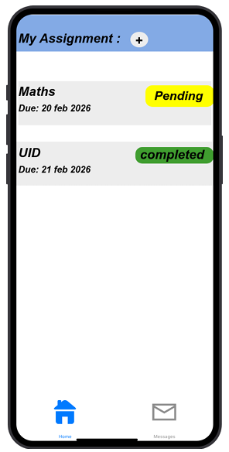
- Dashboard Screen:

Familiar Elements:
- Card Layout for Assignments:
o Commonly used in task and productivity apps.
o Displays subject, deadline, and status clearly.
- Plus (+) Icon:
o Universally recognized for adding new items.
o Clicking it allows adding assignment.
- Bottom Navigation Bar:
o Standard mobile navigation pattern.
o Includes Home and Profile options.
- Status Labels (Pending / Completed):
o Clearly shows task condition.
o Similar to to-do list apps.
Possibly Unfamiliar Elements:
- Color-coded Status (Yellow/Green):
o Some users may take time to understand meaning of colors.
- No Separate Add Screen (if popup used):
o Some apps open a new page instead of inline action.
- Profile Screen
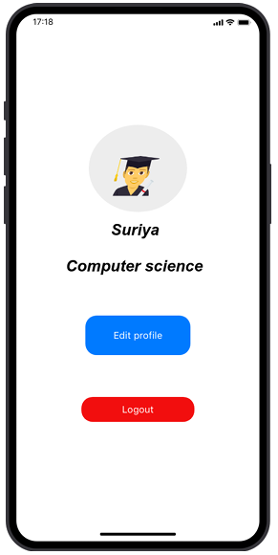

Familiar Elements:
- Circular Profile Image:
o Common UI pattern for user identity.
o Used in most social and productivity apps.
- Edit Profile Button:
o Standard option for updating personal details.
- Logout Button:
o Common account management feature.
o Clicking logs out of application.
- Toggle Switch (Dark Mode):
o Familiar UI element for enabling/disabling features
Possibly Unfamiliar Elements:
- Dark Mode Inside Profile Page:
o Usually placed under Settings in some apps.
o Placement here may be slightly different.
Proto.io link :
https://pr.to/L8VHN5/

